**تمرین اول**

**نرگس خاتمی**

import cv2  
import numpy as np  
import matplotlib.pyplot as plt  
image = cv2.imread('images/volleyball.JPG')  
plt.imshow(image[...,::-1])

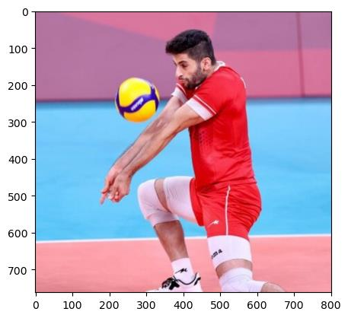

height, width = image.shape[:2]  
# Simply use indexing to crop out the rectangle we desire  
cropped = image[50:350 , 200:500]  
plt.imshow(cropped[...,::-1])  
<matplotlib.image.AxesImage at 0x1ff90a532e0>

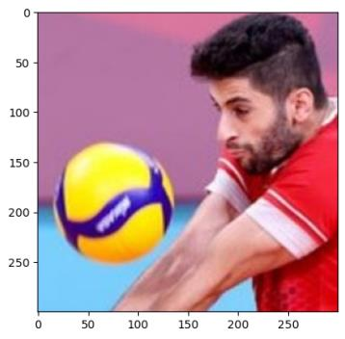

cv2.imshow("original", image)  
cv2.imshow("cropped", cropped)  
cv2.waitKey()  
cv2.destroyAllWindows()